Welcome To Group 6

Topic: Hard Drive Partition Scheme( MBR & GPT )

----------------Definition----------------
* Hard Drive ?
is a storage for store data permanently.

* Partition :
_is the creation of one or more regions on secondary storage
_that each region can be managed separately
_partitions: primary, extended, and logical

Ex: (D:)100GB for education, (E:)250GB for entertainment it depends on the person who owns the device.

* Before a hard disk can be used it needs to have a partition scheme configured on it.

* The partition scheme allows the hard disk to be divided up into partitions.

* Hard Drive partition?
Is a section of
-----------------------------------------------------
* MBR (master boot record)? Legacy boot
* GPT (GUID partition table)?

MBR and GPT are partition table.

Note: they are doing the same thing: manage how partitions are created and organized on a hard disk

Capacity:
------------------MBR--------------------

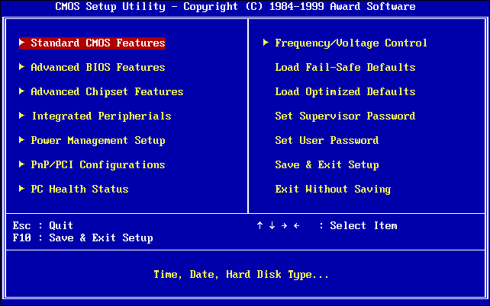
1. Master boot record The MBR, short for Master Boot Record, is an old and commonly-used disk layout.

2. MBR a partition table can hold maximum number of 4 entries for primary partitions in Windows.

3. MBR a partition table can hold maximum number of 4 entries for primary partitions in Windows.

We have said an
4. MBR disk can hold 4 primary partitions at most while a GPT disk supports up to 128 primary partitions in Windows

5. If you want to create more partitions, you have to create an extended partition where lots of logical partitions could reside. However, a logical partition can't be set active.

------------------GPT--------------------

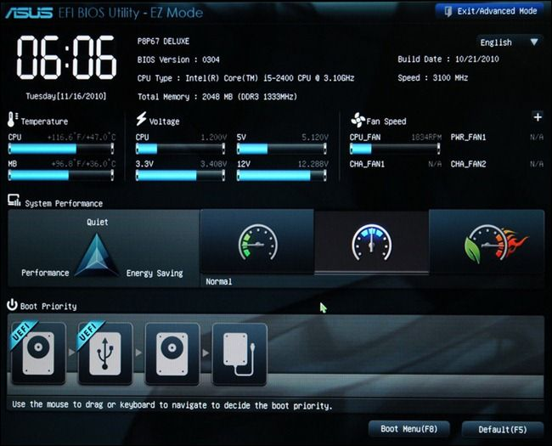
1. GUID partition table Note: (GPT) disks use unified extensible firmware interface (UEFI)

The GPT, short for Globally Unique Identifier Partition Table, is a new disk layout associated with UEFI.

2. GPT is better if you are planning to create more than 4 partitions.

3. GPT disk theoretically allows an almost unlimited number of partitions, but Windows implementation restricts it to 128 partitions.

